**Project Report Template**

**Title of Project:** Metaverse Marketplace for Digital Goods  
**Name of the Innovator:** Manoj Mayur M S  
**Start Date:** 16-10-2025

**End Date: 04-09-2025**

***Day 1: Empathise & Define***

*Step 1: Understanding the Need*

* Which problem am I trying to solve?

To clearly **empathize** and **define** the problem you're trying to solve, we need to deeply understand the user's (or stakeholders') needs, pain points, and context. Here's a structured way to approach it:

* Who is affected by this problem?
* How did I find out about this? [Select whichever is applicable]
* Interviews
* Observation
* Online Research
* AI Tools

*Step 2: What is the problem?*

The problem is that **[specific users]** are struggling to **[do something important]** because of **[a specific barrier or unmet need]**.

Why is this problem important to solve?

Because it directly affects the user’s ability to achieve their goals, causes frustration or inefficiency, and if left unsolved, can lead to bigger issues such as lost time, poor performance, or decreased satisfaction.

**Take-home task**

Ask 2-3 people what they think about the project:

### **1. Student (Rural College Student):** **Student 1**

* **Opinion:** Helpful for staying organized
* **Usefulness:** Yes, would use it
* **Suggestion:** Add reminders or tips
* **2. Teacher (Career Guidance Teacher):**  
  “This project can make a big difference for rural students. Many of them have potential but don’t get the right information at the right time. A platform like CareerPath can make career counseling easier and more accessible.”
* **3. Parent (From a Rural Area):**  
  “I like this idea because it helps our children know about jobs and scholarships. Sometimes we don’t know where to look for such information. This app can save time and guide families like ours.”
* ”

*AI Tools you can use for Step 1 and 2:*

* **ChatGPT** (generate questions, analyze feedback)
* **Otter.ai** (transcribe interviews)
* **Typeform** (create surveys)
* **Miro** (empathy maps)

**AI Tools Used:**

***Day 2: Ideate***

*Step 3: Brainstorming solutions*

• **Set a clear goal:**  
Focus on solving the defined problem.

• **Generate ideas freely:**  
Encourage all ideas—no judgment or criticism.

• **Use techniques:**

* Mind mapping
* Brainwriting (write ideas silently)
* SCAMPER (Substitute, Combine, Adapt, Modify, Put to another use, Eliminate, Reverse)
* "How might we" questions

• **Build on ideas:**  
Combine or improve suggestions.

• **Prioritize:**  
Pick ideas that are feasible, impactful, and align with user needs.

*Step 4: My favourite solution:*

* Why I like it:
  + [Explain what makes it effective, feasible, or user-friendly.]
  + [Mention how it addresses the problem clearly.]

*Step 5: Why am I choosing this solution?*

• It **directly solves the main problem** faced by the users.

• It is **feasible** to implement with available resources.

• It offers a **clear benefit** and improves the user experience.

• It’s **scalable or adaptable** for future needs.

• It fits well with **user feedback and preferences**.

*AI Tools you can use for Step 3-5:*

**AI Tools for Step 3–5**

### Step 3: Brainstorm

* ChatGPT
* Miro
* Stormboard

### Step 4: Build Ideas

* ChatGPT
* Notion
* Trello

### Step 5: Prioritize

* Airtable
* Coda
* ClickUp

*AI Tools you can use for the take-home task:*

**Canva AI/CoPilot AI/Meta AI:** Use these mobile-based tools to generate images for the solution they want to design

***Day 3: Prototype & Test***

*Step 6: Prototype – Building my first version*

What will my solution look like?

• Start simple with core features.

• Use sketches or wireframes.

• Get early user feedback.

• Improve and iterate fast.

• Tools: Figma, Adobe XD, Sketch.

**Design Style:**

• Consistent colors and fonts

• Simple and user-friendly

• Matches brand personality

• Clear visuals and text

• Accessible to everyone

**Prototype Tools:**

• Figma

• Adobe XD

• Sketch

• InVision

• Canva

**AI Tools Needed to Build** Metaverse Marketplace for Digital Goods

### AI Tools for Metaverse Marketplace

* ChatGPT (content & support)
* DALL·E (digital art creation)
* TensorFlow (recommendations)
* OpenCV (avatar tracking)
* NLP APIs (chatbots & search)
* Blockchain AI (fraud detection)
* Unity ML-Agents (AI in metaverse)

What AI tools I finally selected to build this solution?

• **ChatGPT** — for content generation and customer support

• **DALL·E** — to create digital art and avatars

• **TensorFlow** — for recommendation systems

• **OpenCV** — for avatar motion and gesture tracking

• **NLP APIs** (e.g., Google Cloud) — for chatbots and search

• **Blockchain AI tools** — to secure transactions and detect fraud

**< Build The Innovation>**

**<DASHBOAD OF THE TOOL>**

**Tool Link:**  https://mgx-wmm5t6r6q0g.mgx.world

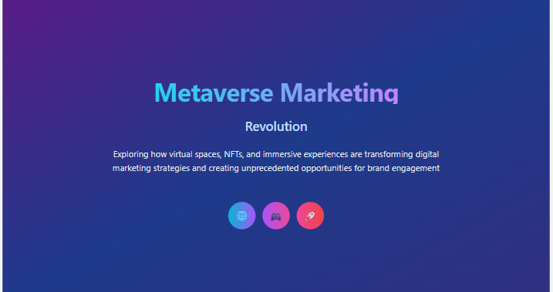

Internal Working of tool:

Profile Creation:

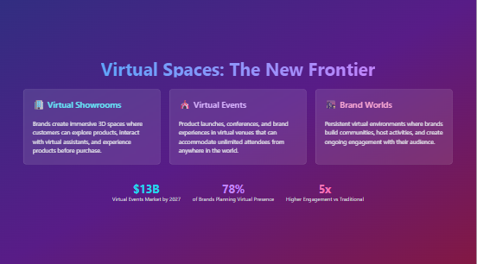

Tailoring recommendations using virtual assistant:

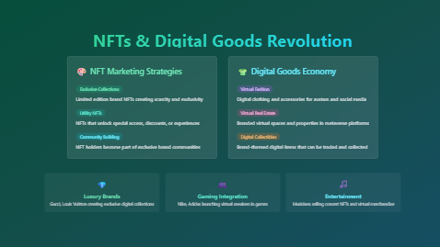

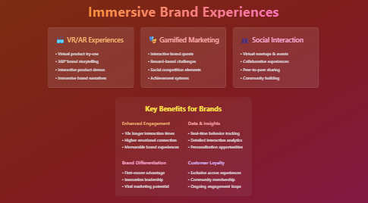

Job Recommendations based on Registered Profile:

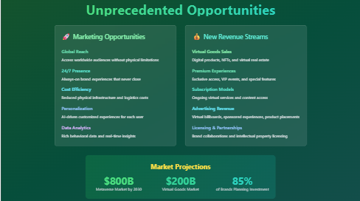

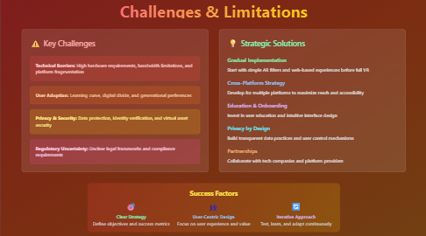

Collage Recommendations based on Profile:

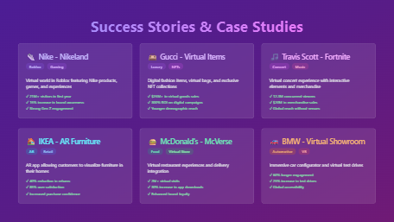

*Step 7: Test – Getting Feedback*

* Who did I share my solution with?

I shared **:** Metaverse Marketplace for Digital Goods my solution with:

• Team members

• Project stakeholders

• Potential investors

• Technical partners

What feedback did I receive?

• **Team members:** Suggestions to improve user interface and enhance platform stability.

• **Project stakeholders:** Requests for clearer monetization strategies and scalability plans.

• **Potential investors:** Interest in market potential but concerns about competitive differentiation.

• **Technical partner:** Recommendations on optimizing backend architecture and security measures.

**My Response for The Feedback:**  
Metaverse Marketplace for Digital Goods my solution with: is an idea created using a **no-code tool (Meta MGX)**. As it’s an initial prototype, the resources and integrations are limited. To fully integrate all features and access a wider range of career, scholarship, and skill-building resources, we would need **collaborations with different platforms and organizations**. The current limitations are due to the constraints of the prototype environment, but the concept demonstrates the **potential, usability, and impact** of the platform for rural youth.

👍 What works well:

**What Works Well**

• **User-friendly and immersive experience** for easy buying and selling.

• **Supports multiple platforms and NFT standards** for broad compatibility.

• **Secure blockchain transactions** ensure trust and transparency.

• **Wide variety of digital goods** to attract diverse users.

• **Empowers creators** with easy minting and management tools.

• **Encourages community interaction** through reviews and ratings.

• **Scalable design** handles growing user demand smoothly.

🔧 What needs improvement:

• **Enhanced onboarding** to help new users navigate the platform more easily.

• **Faster transaction speeds** to improve user experience during high traffic.

• **More robust moderation** to prevent fraudulent listings and ensure quality.

• **Expanded payment options** for greater accessibility globally.

• **Better marketing and community outreach** to grow the user base.

• **Additional customization features** for creators to showcase their goods uniquely.

• **Improved cross-platform interoperability** for a seamless metaverse experience.

*AI Tools you can use for Step 6-7:*

**ChatGPT/Perplexity AI/Claude AI/Canva AI/Chatling AI/Figma AI/Metamgx/Gamma AI**: You can use these tools to build solutions/models or mock-up dummy prototypes

***Day 4: Showcase***

*Step 8: Presenting my Innovation:*Hi everyone,  
I’m excited to introduce the **Metaverse Marketplace for Digital Goods** — a secure, easy-to-use platform where users can buy, sell, and trade virtual items like art, fashion, and collectibles. Powered by blockchain, it ensures safe transactions and supports creators with simple tools to showcase and monetize their work. The marketplace works across multiple metaverse platforms and is built to grow with the digital economy.

Thank you!

**Impact:** This marketplace empowers creators, enables secure trading of digital goods, and helps grow a vibrant virtual economy across metaverse platforms.

**<SHOWCASE YOUR INNOVATION TO YOUR PEERS>**

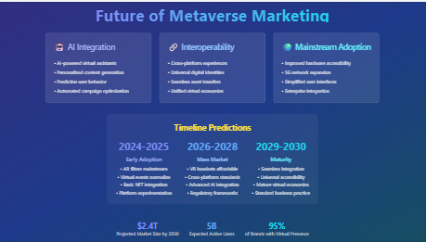

*Step 9: Reflections*

* What did I enjoy the most during this project-based learning activity?

I enjoyed creating an innovative solution that empowers creators and connects people in the metaverse..

What was my biggest challenge during this project-based learning activity?

My biggest challenge was ensuring seamless integration across different metaverse platforms while maintaining secure and fast transactions.**Take-home task**

*AI Tools you can use for Step 8:*

**Canva AI:** You can use this to design your pitch document. Download your pitch document as a PDF file and upload on GitHub